Exam 1 – Practice 1
Exam Guidelines This is an in-class, written exam with a 75-minute time limit.
- Permitted Materials: You may use a basic calculator and a formula sheet.
- Formula Sheet Restrictions: Your sheet must contain formulas only; no examples or worked problems are permitted. All sheets will be inspected at the start of the exam.
- Prohibited Items: Phones and all other smart devices are strictly forbidden.
- Academic Integrity: The use of AI is prohibited. Any AI usage will result in an automatic F for the exam and may lead to failing the entire course.
- Graph the below line.
- $y=2x+1$
- $y=5$
- $x=3$
- Write the equation of the line
- passing through two points (1, 2) and (4, 3)
- with the slope of 3 and passing through (1, 2)

- Match each equation to its corresponding graph.
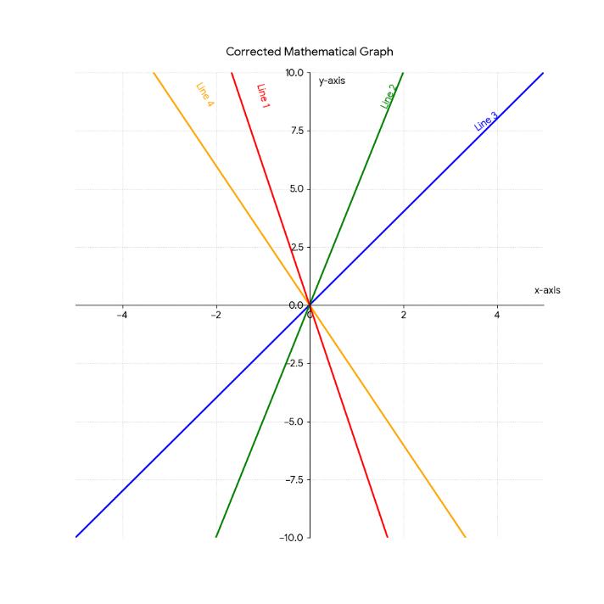s
- $y=2x$
- $y=5x$
- $y=-3x$
- $y=-6x$

- You manage a local craft shop that sells handmade artisan coffee mugs. Market research indicates that you can sell 150 mugs per month if they are priced at $10 each, but you will only sell 50 mugs per month if the price is increased to $20 each. On the other side, your supplier is willing to provide 30 mugs per month if the retail price is $8 each but will increase production to 130 mugs per month if the retail price reaches $18 each.
a. Write the linear demand and supply functions.
b. Find the equilibrium point. At what price must the mugs be sold for supply to exactly equal demand?
c. Graph both the demand and supply functions on the same axis.

- A company that prints custom T-shirts has fixed monthly costs of $60,000 and variable costs of $30 per T-shirt produced. Each T-shirt sells for $90.
a. Find the cost function.
b. Find the revenue function.
c. Graph and clearly label the cost and revenue functions on the same set of axes. Identify and label the break-even point.
d. Find the profit function.
e. How much profit will the company make by producing and selling 1,500 T-shirts?
f. How many T-shirts must be produced and sold in order to obtain a profit of $60,000?

- Two investment options that earn simple interest are available.

Investment A starts with $1,200 and earns simple interest at an annual rate of 4%.
Investment B starts with $2,000 and earns simple interest at an annual rate of 2%.

- Write a linear equation that represents the total amount of money in each investment after t years.
- How much money will there be in Investment A in 3 years?
- When will investment A reaches $1488?
- Determine which investment grows faster and explain your answer by comparing the slopes of the two equations.
- Determine whether the two investments will ever have the same total value. If so, find when this occurs.
- Plot both investment functions on the same coordinate system.

